1. Find Standard BAdI using CL_EXITHANDLER=>GET_INSTANCE

Go to the Transaction, for which we want to find the BADI, in our case we will take the example of Transaction MM02.

Search for any Material.

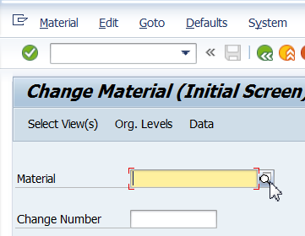

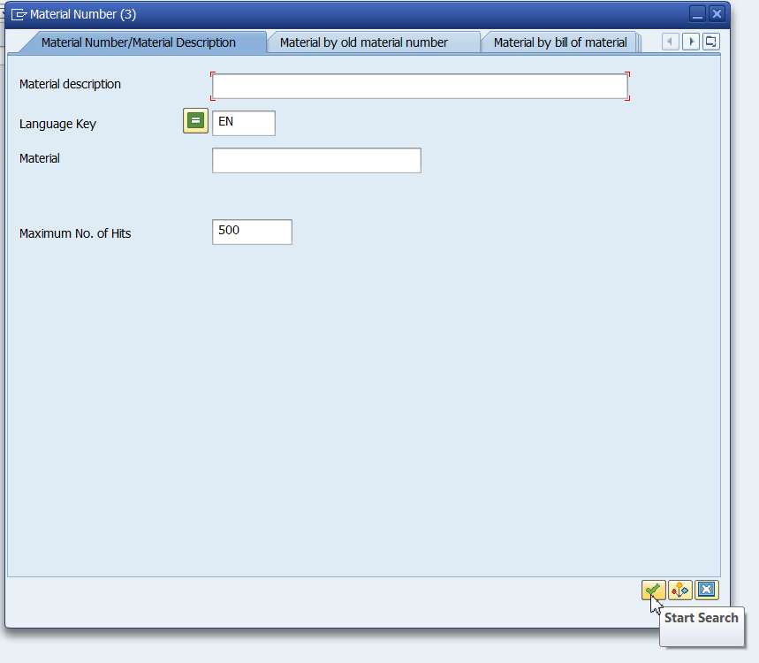

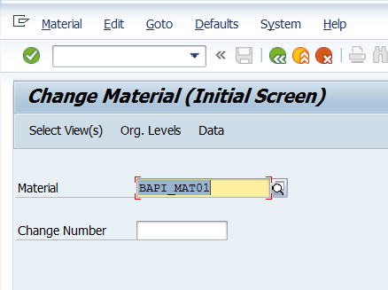

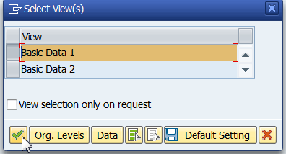

1. Get the Program Name of Corresponding Transaction.

(Click on System->Status. Double Click on Program Name).

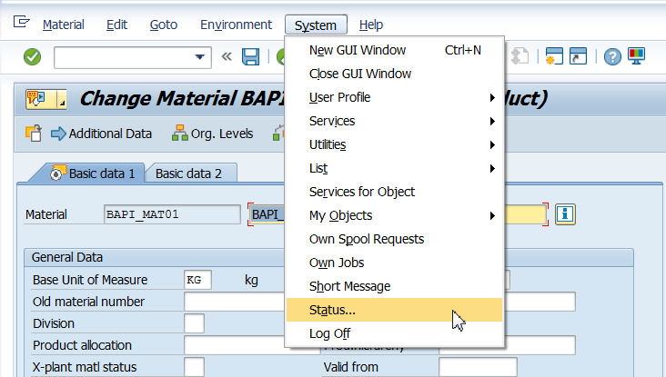

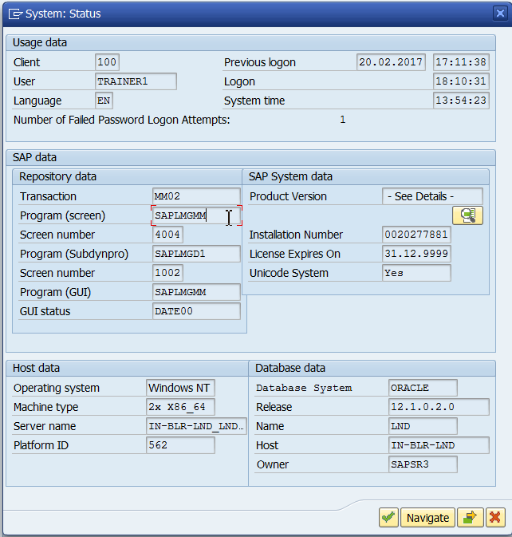

1. Once inside the program search for ‘CL_EXITHANDLER=>GET_INSTANCE

Make sure the radio button “In main program” is checked.

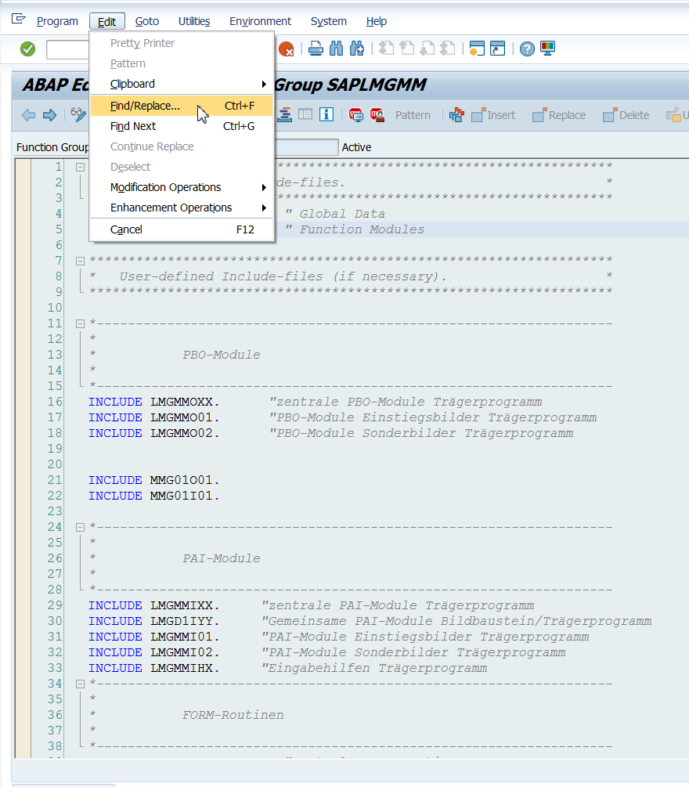

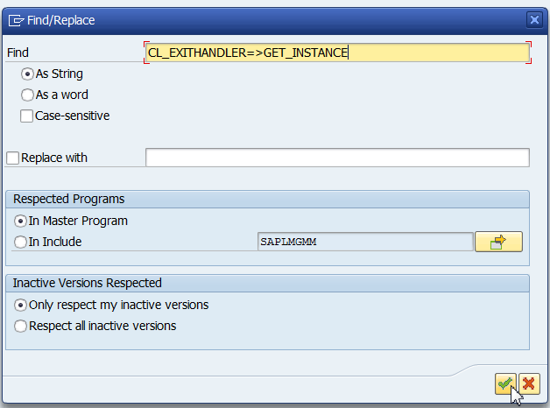

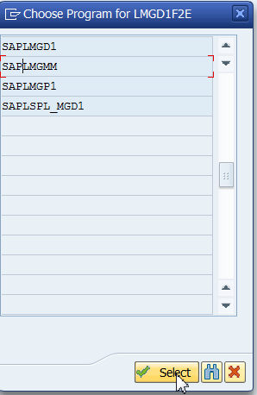

* + A list of all the programs with call to the BAdI’s will be listed.
  + The export parameter ‘EXIT_NAME’ for the method GET_INSTANCE of class CL_EXITHANDLER will have the user exit assigned to it.

The changing parameter ‘INSTANCE’ will have the interface.

